Mini OBD Bluetooth4.0 Diagnosis Scanner
User Guide

Note:This specification applies to our company’s Mini OBDII bluetooth codes reading card of model CY-B21 .

Product Name：Mini OBD Bluetooth4.0
Product Model：CY-B21

1.Specification：
Technology: Bluetooth 4.0
System: Support Android / IOS/Windows
Working Voltage: 9V~16V
Working Current: 45mA
Working Temperature : -40℃~85℃
Working Humidity: <60%
Size: 47mm*24mm*25mm

2.Features：
- Usage：
Read diagnostic trouble codes—— both generic and manufacturer-specific，and display their meaning (over 3000 generic code definitions in the database).
Clear trouble codes and turn off the MIL ("Engine Check " light).
Display current sensor data, including:
Engine RPM
Load Value After Calculating
Coolant Temperature
Fuel System Status
Vehicle Speed
Short Term Fuel States
Long Term Fuel States
Intake Manifold Pressure
Injection advanced time
Intake Air Temperature
Air Flow Speed
Absolute Position of Throttle
Oxygen sensor voltages associated to short term fuel States
Fuel System status
Fuel Pressure

Fuel consumption detection and many other data……
The features in future :
Data display in chart and data logging
Freeze Frame Data
Continuous and discontinuous oxygen detective results

3.Protocol Support：
Mini OBDII can support protocol below ：
J1850VPW

J1850PWM
ISO 9141-2 (5 baud init, 10.4 Kbaud)
ISO14230-4 KWP (5 baud init, 10.4 Kbaud)
ISO14230-4 KWP (fast init, 10.4 Kbaud)
ISO15765-4 CAN (11bit ID, 500 Kbaud)
ISO15765-4 CAN (29bit ID, 500 Kbaud)
ISO15765-4 CAN (11bit ID, 250 Kbaud)
ISO15765-4 CAN (29bit ID, 250 Kbaud)

4.System:
Compatible Software:
Window Version: ScanMaster-ELM, ScanTool.net, PCMSCAN and so on；
Android Version: Mini OBD II ,Torque, DashCommand, OBD Car Doctor and so on ；
Symbian version：OBD Scope。
Apple version ：Mini OBD II ,DashCommand, OBD Car Doctor；geekobd;
Compatible System
System support ：Windows XP，Windows 7/8，Android ，Symbian， Apple and so on。

5.Description：

- Appearance：
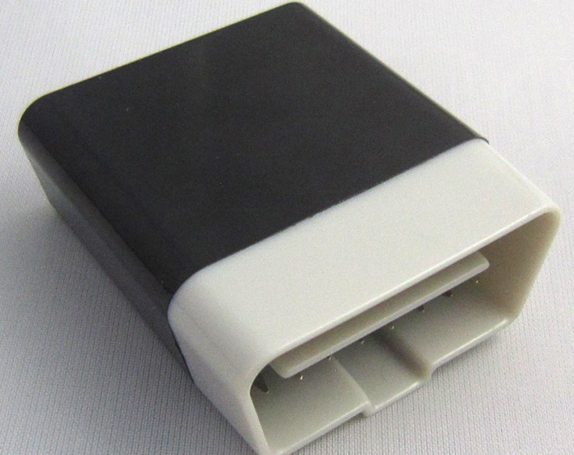

Port：16pin OBDII standard port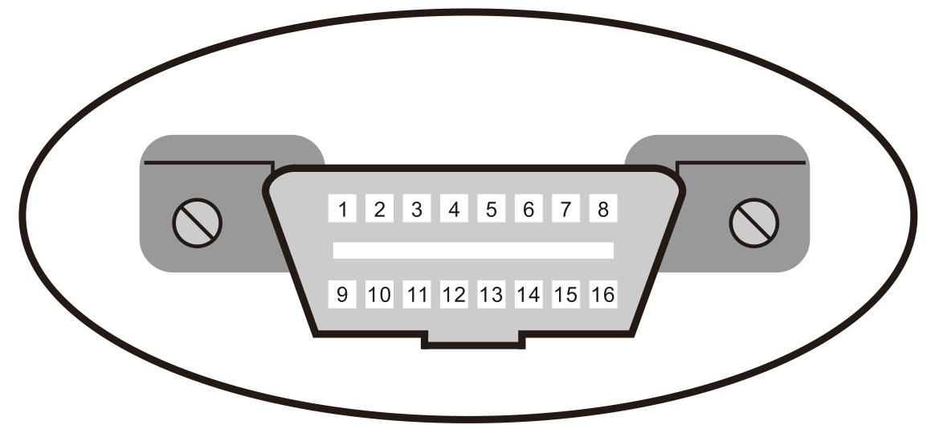

6.How to use:

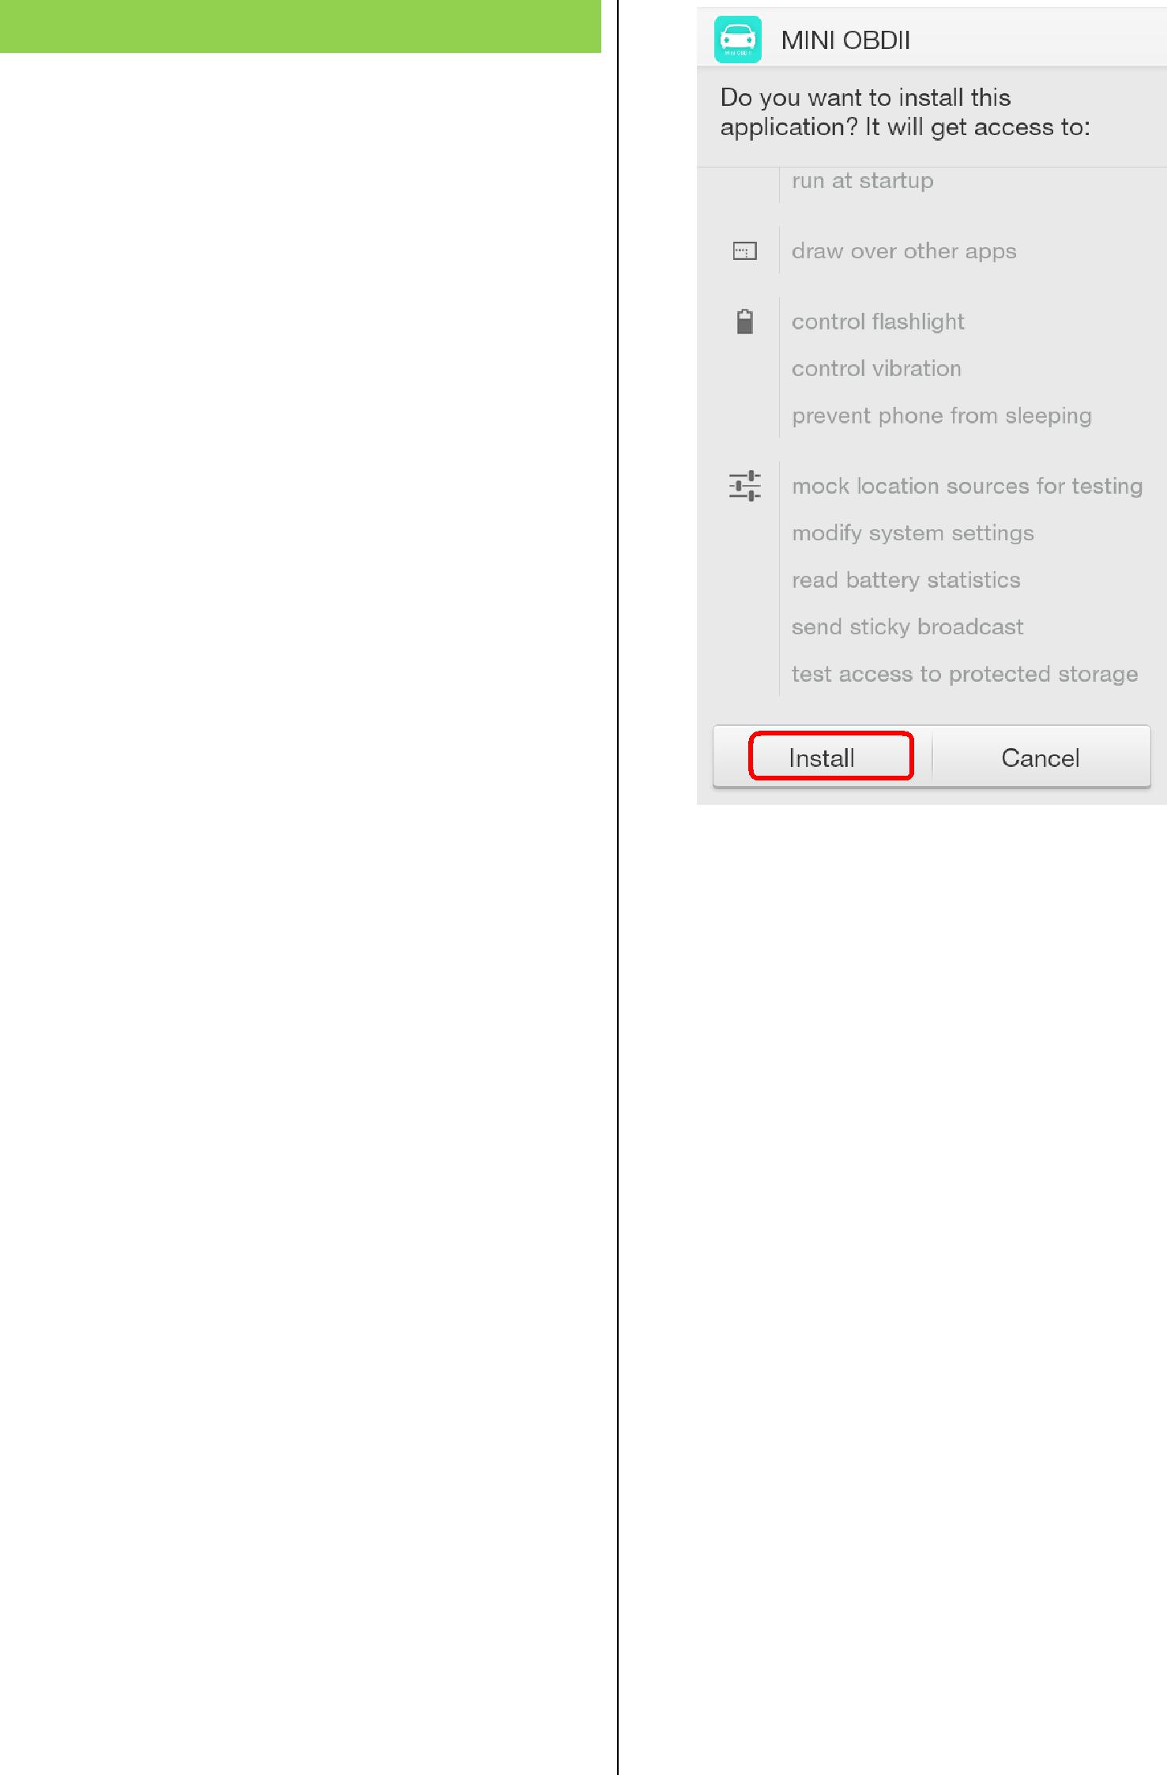
Mini OBDII for Phone

1. Plug in OBDII adapter, start car engine
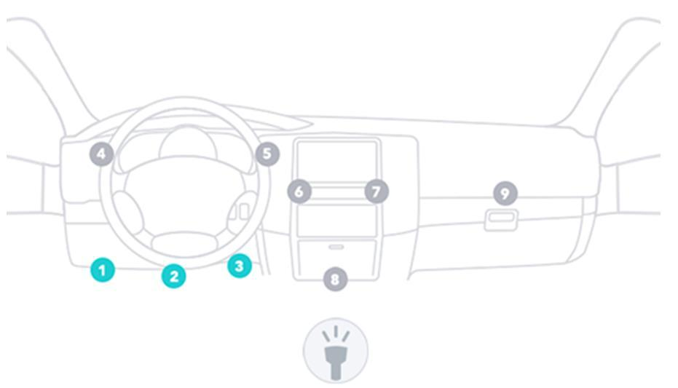

- Install Software “Mini OBD”

- Scan RQ Code below to download the APP
Mini OBD II for Android

Mini OBD II for IOS

3. Launch Software “Mini OBDII”

a) Register and login your account

- Install Software

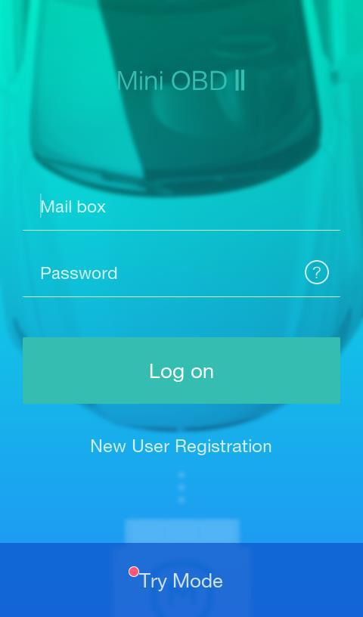

- 2 -

- Click at the Icon on the top right.
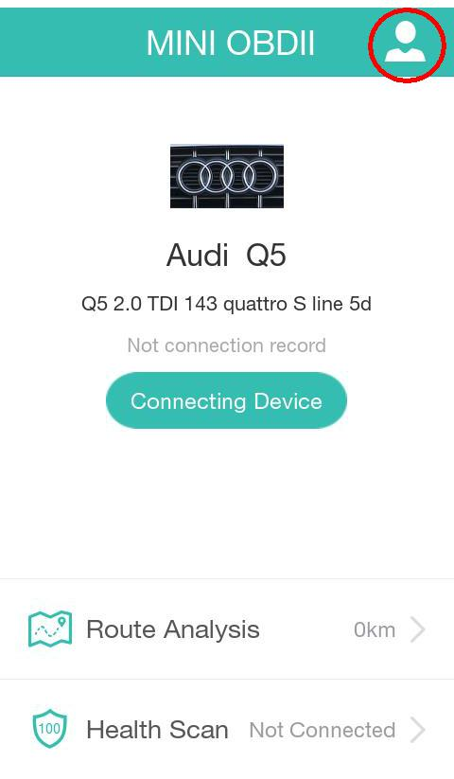

- Click at “Vehicles Setting” and select the model of your car.
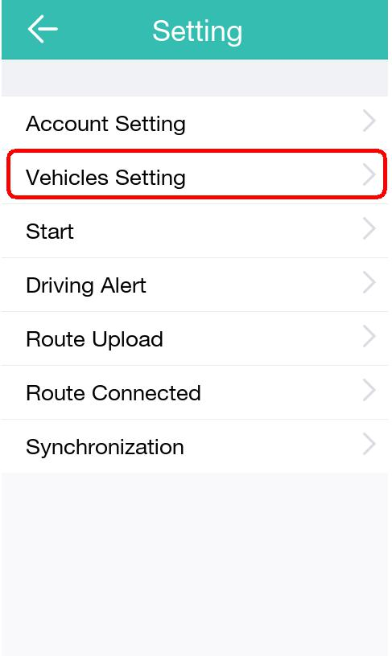

- Connect with OBDII Adapter

- Click at “Connecting Device” to prepare for OBDII adapter connection.
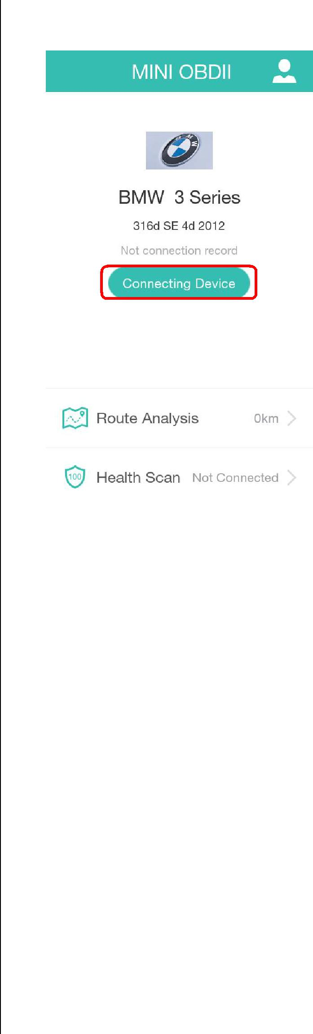

- Click at “Device Plugged please scan now” to scan the OBDII Bluetooth.
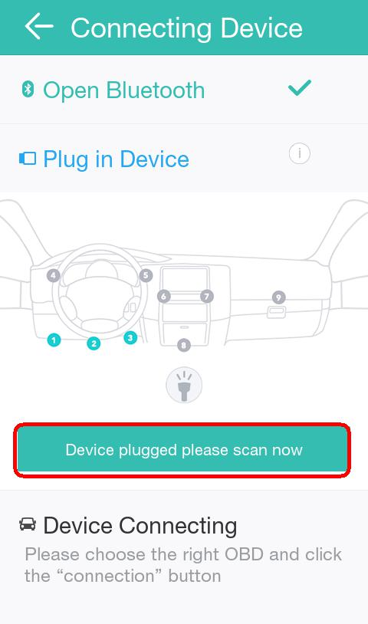

- 3 -

c) Locate Bluetooth OBDII and click at Connect | HUD Display
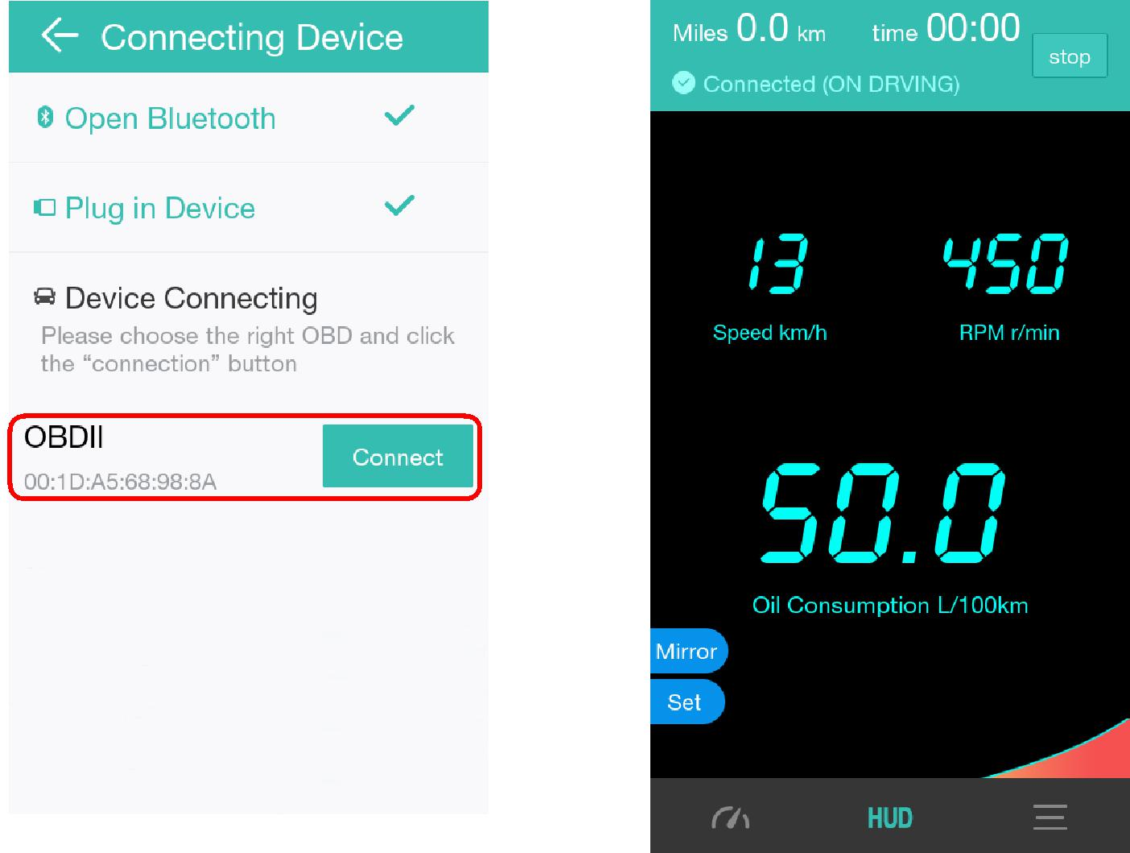

Vehicle Real Time Data
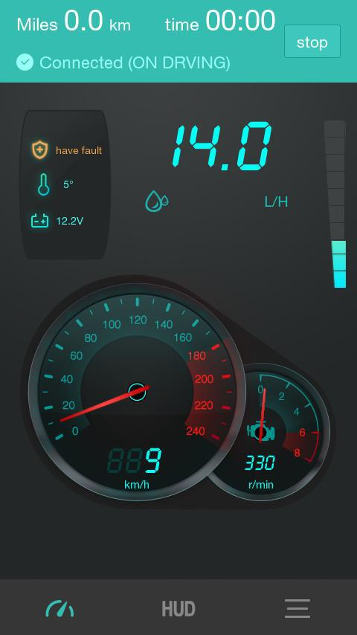
Vehicle Real Time Data Stream
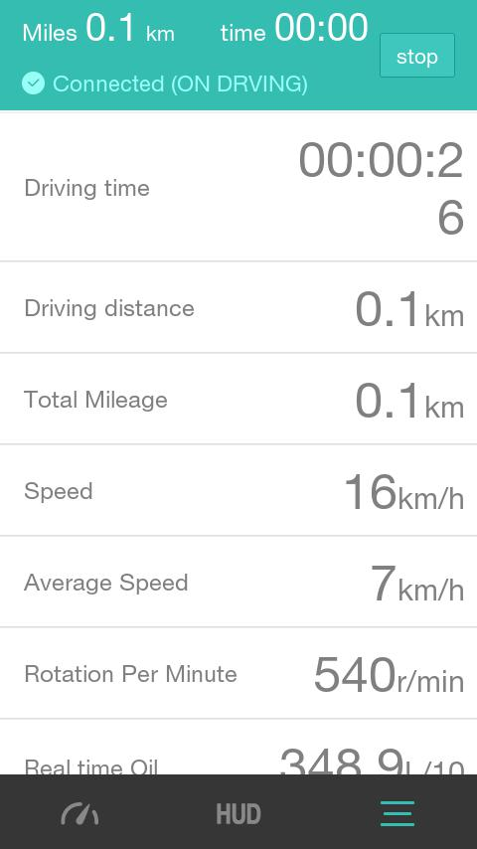

- 4 -

Route Analysis | Clear Fault Codes
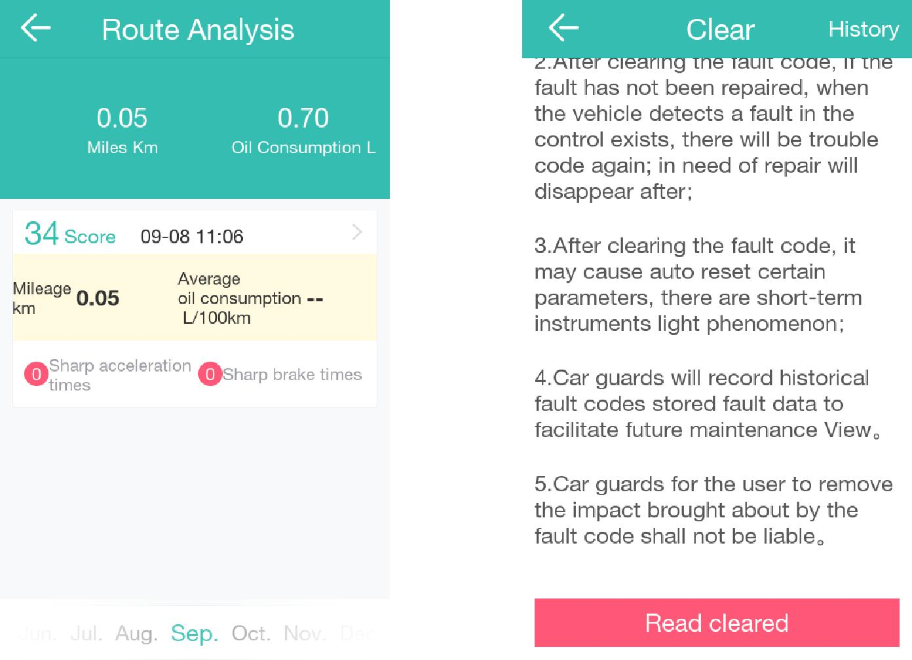

Health Scan
