https://detail.1688.com/offer/44903784328.html?spm=a2615.7691456.0.0.Pn6ylb

Bluetooth Handfree Car Kit FM Transmitter Wireless stream Music with LED Display and Dual Charging Port

1.Wirelessly stream music and phone call from Bluetooth mobile phone to the car FM stereo system;
2.Switch to Hands-free mode automatically from music playing status when receiving calls;
3.Clear and lossless sound to make enjoy music in car more comfortable.
3.Built-in Microphone
4. Dual USB charge for mobile phone and other devices (outputs 5V/2.1A)
5.Support USB Disk/ TF Card
6.Strong and elegant design with LED frequency display.
7.With voice prompts

- Specification:
- Chips: MTKIC
- Frequency range: 87.5-108.0MHZ
- Frequency stability: ±10ppml
- Product Input:12-24V
- Charger output : 5V/2.1A(in total)
- Music Format: mp3, wma
- TF Card( Max capacity): 32GB
- USB Disk (Max capacity):32GB
- Product Total Output: 5V/3.4A
- Audio input: 3.5mm stereo jack
- Transmit Distance: about 10m

Compact and Delicate Design
Portable design save more space in car , elegant appearance with LED frequency display give you good feeling when you touch. And a screw added in its main body fixed it to make it stronger and not split and durable.
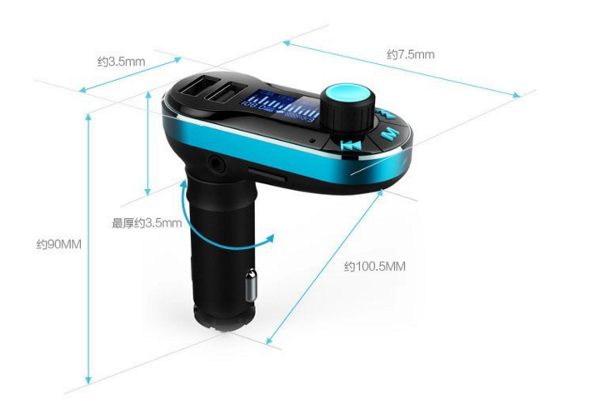

Easy to Conduct

Multiple functional button, easy to conduct , press just 1 button you can answer /hang up/redial calls, also you can choose the next or previous song or adjust the volume by the rotation button.
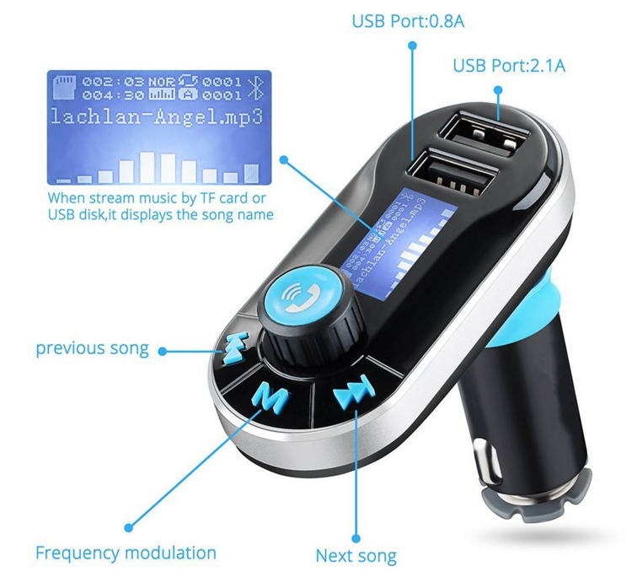

Clear Sound and Wide Usage
Adopted with high quality MTKIC chips, It can not only transmit phone calls clearly from your car to car stereo but also can play sound lossless and beautiful music files from USB disk and TF card and it has a 3.5mm Aux jack can connected to external device too! Dual charging port can support both mobile phone and tablet.
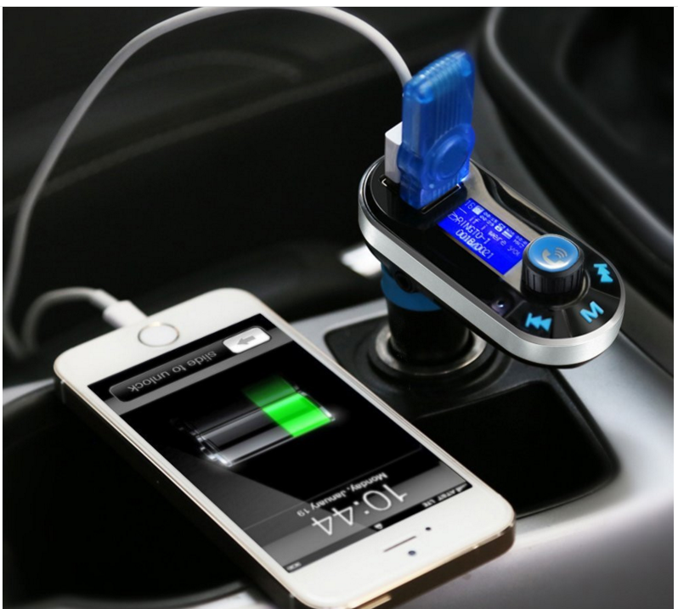
(Note: Please make sure only the port close to the knob can insert USB disk or USB reader )

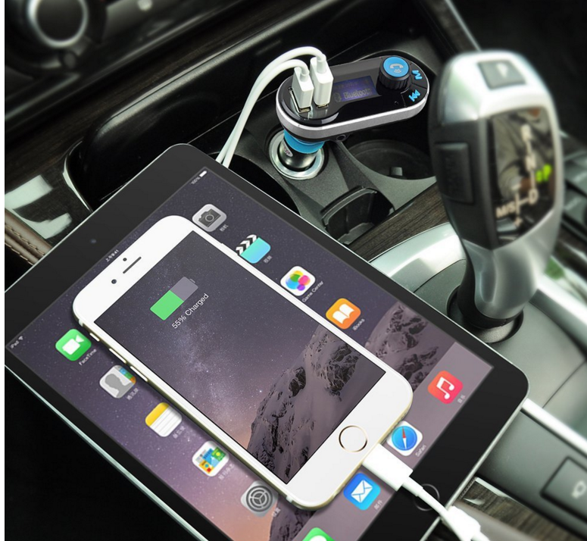
(NOTE: Only the port far away from the knob can charge Ipad)
Make Driving Safer
With built-in microphone and when there is a call incoming , it will switch to hands-free mode automatically from music playing status that not need your hands get off the steering wheel to make driving safer.

Package include:
1 X BT Handfree Car Kit
1 X User Manual
1 X Aux In cable

