安全座椅收纳袋 | FB0235B-A08
产品信息：
品名：安全座椅旅行收纳袋
材质：1680D牛津布
颜色：黑色
重量：678g
尺寸：长宽高18"*18"*34"（即46cm*46cm*86.5cm）
包装材料：PP塑料袋
包装尺寸：27x25.5x5cm

About the Product:
- Product Name: Car Seat Travel Bag
- Material: 1680D Oxford Fabric
- Color: Black
- Item Weight: 714g
- Size: 18"Lx18"Wx34"H
- Package Size: 27x25x7cm

产品细节：Product Details:
- 1680D牛津布：High Quality 1680D Oxford Fabric
- 带拉链的收纳小包：Build -in Zipper Carrying Case Pocket
- 背面双肩+垫片：Padded Backpack Straps
- 束口绳：Adjustable Drawstring Closure
- 红色织带+插扣：Red Straps with Buckles
- 白色易碎标签：FRAGILE Warning Sign
- 正面提手：Front Handle for Easy Lifting
- 放ID卡的小口袋：Name Card Holder

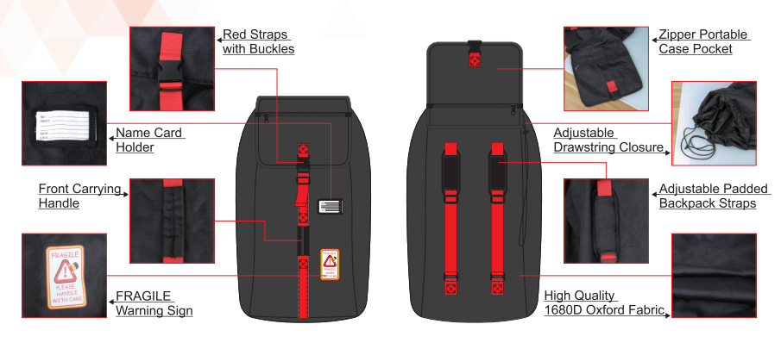

产品功能：
- MODOKIT安全座椅旅行收纳袋配有双肩带可以让您为儿童安全座椅解放双手，这样您就可以很容易地出示机票，抱您的宝宝，甚至可在机场喝杯咖啡。
- 通过保护您的安全座椅不受灰尘和细菌的侵害来保护婴儿的健康和安全，不管您是在坐飞机旅行，还是只是把它们放在汽车后备箱或车库中。
- 产品尺寸18"*18"*34"，通用设计适用于大多数品牌的婴儿安全座椅。
- 由耐脏防水耐撕裂1680D牛津布材质制成，可长期使用。前面方便携带的提手，便于打开和关闭的可调节拉绳，可通过显眼的ID持有人的名片可以很轻易辨认出您的旅行收纳袋。
- 易收纳:不用时可以折叠装进带拉链的小包里（收纳袋连同产品一起不会丢失）

Product Functions:
- MODOKIT car seat travel bag comes with the backpack straps allow you to carry your child’s car seat hands-free, so that you can easily show tickets, hold your baby or even sip a cup of coffee at the airport.
- Protects your car seats from dirt and germs, helps you keep your baby healthy and safe whether you are traveling by airplane, or simply storing in the car trunk or garage.
- Product size is 18"x18"x34". Universal design fits almost all major brands car seats.
- Made of complete stain-resistant, water resistant, wear and tear resistant 1680D Oxford Fabric for long-lasting use. Convenient front handle for easy carrying, a drawstring closure and adjustable lock for easy opening and closing. Easy identify your travel bag with red straps and clear ID card when you are in boarding gate or departure gate.
- It can be folded when not in use into the build-in small and easy-carry case pocket with hand strap for easy storage.

产品描述：
MODOKIT 通用款轻型黑色安全座椅旅行背包，使您旅行时非常容易携带一个婴儿汽车安全座椅。坐飞机时，有了我们的安全座椅旅行收纳袋，让您过安检时，不麻烦!
Product Description:
MODOKIT universal lightweight black car seat travel backpack makes you extremely easy to carry a baby car seat when you travel. With our car seat bag for traveling by airplane, you can gate check the bag and hassle-free!

推车收纳袋 | FB0236B-A08
产品信息：
品名：儿童推车旅行收纳袋
材质：1680D牛津布
颜色：黑色
重量：990g
尺寸：长宽高24"*18"*47"（即61*46*119.5cm）
包装材料：PP塑料袋
包装尺寸：25.5x32.5x7.5cm

About the Product:
- Product Name: Car Seat Travel Bag
- Material: 1680D Oxford Fabric
- Color: Black
- Item Weight: 714g
- Size: 18"Lx18"Wx34"H
- Package Size: 27x25x7cm

产品细节：
1.1680D牛津布：High Quality 1680D Oxford Fabric
2.带拉链收纳小包：Build -in Zipper Carrying Case Pocket
3.背面双肩+垫片：Padded Backpack Straps
4.2条术口绳+插扣：2 Adjustable Drawstrings Closure and Buckle
5.白色易碎标签：FRAGILE Warning Sign
6.正面提手：Front Handle for Easy Lifting
7.ID卡：ID Card with Name Card Holder
产品特性：
1.大容量，双肩带可以为您的儿童推车解放双手
2.保护您的婴儿车或汽车座椅不受灰尘和细菌的侵害，不管您是在坐飞机旅行，还是只是把它们放在汽车后备箱或车库中，帮助父母保护婴儿健康。
3.产品设计适用于大多数双推车，标准轻推推车。
4.方便携带的提手，顶部可调节拉绳，便于打开和关闭，中间拉链便于调节松紧度。
5.耐脏耐用的防水耐撕裂1680D牛津布材质。
6.可通过显眼的ID持有人的名片可以很轻易辨认出您的旅行收纳袋。
7.易收纳:不用时可以折叠装进带拉链的小包里（收纳袋连接产品一起不会掉）

MODOKIT STROLLER TRAVEL BAG

- 1680D牛津布：High Quality 1680D Oxford Fabric
- 带拉链收纳小包：Zipper Carrying Case Pocket
- 背面双肩+垫片：Adjustable Padded Backpack Straps
- 2条术口绳+插扣：2 Adjustable Drawstrings Closure and Buckle
- 白色易碎标签：FRAGILE Warning Sign
- 正面提手：Front Carrying Handle
- 放名片的口袋：ID Card with Name Card Holder

产品功能：

- Huge capacity and the backpack straps allow you to carry your child’s car seat hands-free.
- Protects your strollers or car seats from dirt and germs whether you are traveling by airplanes, or simply storing in the car trunk or garage, helps parents keep their baby healthy.
- Created to fit most double strollers / dual strollers, standard jogging strollers.
- Convenient carrying handle, a drawstring closure and adjustable lock for easy opening and closing, drawstring in the middle of storage bag for snug fit.
- Made of stain-resistant, water resistant and rip resistant 1680D Oxford Fabric for long-lasting use.
- Easy identify your travel bag with clear ID card with name card holder.
- It can be folded when not in use into the small and convenient carrying case pocket with hand strap for easy storage.

推车收纳袋+安全座椅收纳袋组合卖 | FB0237B-A08
产品信息：
品名：推车收纳袋+安全座椅收纳袋
材质：1680D牛津布
颜色：黑色
重量：1667g
尺寸：长宽高24"*18"*47"（即61*46*119.5cm）
包装材料：PP塑料袋
包装尺寸：33x24x14cm

产品细节：
1.1680D牛津布：High Quality 1680D Oxford Fabric
2.带拉链收纳小包：Build -in Zipper Carrying Case Pocket
3.背面双肩+垫片： Padded Backpack Straps
4.术口绳+插扣：Adjustable Drawstring Closure and Buckle
5.白色易碎标签：FRAGILE Warning Sign
6.正面提手：Front Handle for Easy Lifting
7.ID卡：ID Card with PVC Name Card Holder
产品特性：
1.大容量，双肩带可以为您的儿童安全座椅和推车解放双手。
2.保护您的婴儿车或汽车座椅不受灰尘和细菌的侵害，不管您是在坐飞机旅行，还是只是把它们放在汽车后备箱或车库中。
3.通用设计，适用于大多数婴儿车、汽车座椅和轮椅。
4.方便携带的提手，可调节拉绳，便于打开和关闭。
5.耐用的防水耐撕裂1680D牛津布材质。
6.可通过显眼的ID持有人的名片可以很轻易辨认出您的旅行收纳袋。
7.易收纳:不用时可以折叠装进带拉链的小包里（收纳袋连接产品一起不会掉）。

MODOKIT CAR SEAT ＆ STROLLER TRAVEL BAG
Backpack Style
放产品图+产品细节特写图

- 1680D牛津布：High Quality 1680D Oxford Fabric
- 带拉链收纳小包：Zipper Carrying Case Pocket
- 背面双肩+垫片：Adjustable Padded Backpack Straps
- 术口绳+插扣：Adjustable Drawstrings Closure and Buckle
- 白色易碎标签：FRAGILE Warning Sign
- 正面提手：Front Carrying Handle
- 放名片的口袋：ID Card with Name Card Holder

产品功能：

- Huge capacity and the backpack straps allow you to carry your child’s car seat or stroller hands-free.
- Protects your strollers or car seats from dirt and germs whether you are traveling by airplanes, or simply storing in the car trunk or garage.
- Universal design that fits most strollers, infant carriers, booster, children’s car seats and wheelchairs.
- Convenient carrying handle, a drawstring closure and adjustable lock for easy opening and closing, drawstring in the middle of storage bag for snug fit.
- Made of stain-resistant, water resistant and rip resistant 1680D Oxford Fabric for long-lasting use.
- Easy identify your travel bag with clear ID card with name card holder.
- It can be folded when not in use into the small and convenient carrying case pocket with hand strap for easy storage.

